**Count Digits of a Number**

Given a number N, the task is to return the count of digits in this number.

**Example:**

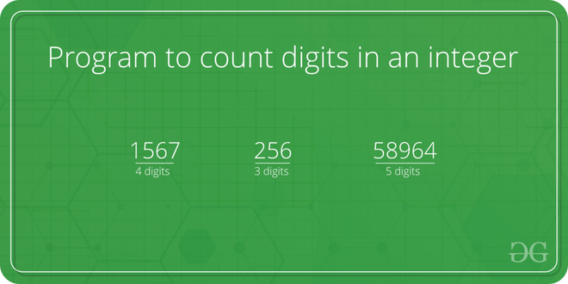

**Simple Iterative Solution to count digits in an integer**

The integer entered by the user is stored in the variable n. Then the while loop is iterated until the test expression n != 0 is evaluated to 0 (false).   We will consider 3456 as the input integer.

1. After the first iteration, the value of n will be updated to 345 and the count is incremented to 1.
2. After the second iteration, the value of n will be updated to 34 and the count is incremented to 2.
3. After the third iteration, the value of n will be updated to 3 and the count is incremented to 3.
4. In the fourth iteration, the value of n will be updated to zero and the count will be incremented to 4.
5. Then the test expression is evaluated ( n!=0 ) as false and the loop terminates with final count as 4.

C++

#include<iostream>

using namespace std;

int main()

{

int count = 0 , n;

cin >> n;

while(n>0)

{

n /= 10;

count ++;

}

cout << count;

return 0;

}

**INPUT :**

231

**OUTPUT :**

3